Renju lesson on April 26, 2001

Hello all! Welcome to Online Renju Class. We will continue our study about d11. Today we will study about another 13th move. As you notice, we still continue with 12-g6 today. There is much to learn about it and we didn’t finish last time. Besides the 13-f7, what are the other possible 13th moves?
You seem to know many moves. Lets begin with 13-h10. Does anyone know the theory of it? Nobody. That’s ok. We will learn it now. It will be very interesting.
The old theory has a powerful attack here. F7 and h5.
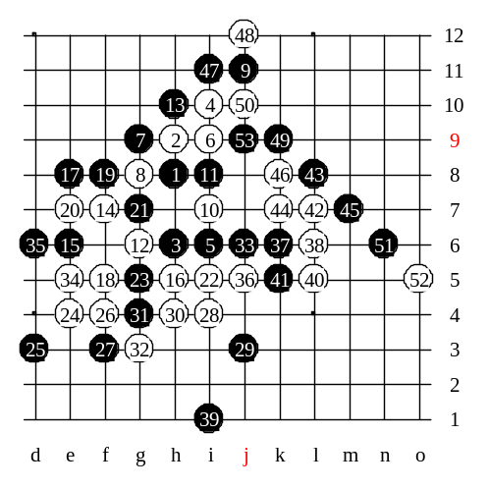
We need f5 point to continue development and control black’s counter-attack towards point i11. White must keep attacking, and not giving black any chance for counter-attack in the upper side. After e4 and f4 white keeps VCF threat. White keeps attacking. Actually white’s attack is very simple. There is only one way to attack. If it fails then white had no chance to win at all. 45-m7 is the key of this variant. From now on, no matter what white does, black defends everything. However, black has to make several careful moves. Watch the sequence. By the 53rd move the variant ends. Black defended! Now black even has an advantage in upper side.

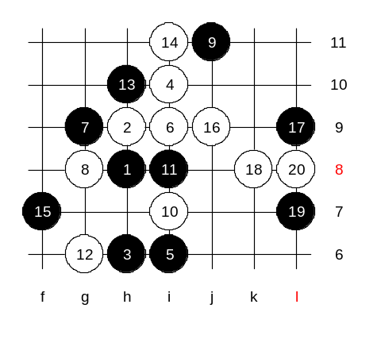
White had a long and powerful attack, full of traps. Black may have easily made a mistake. But in high level games, we cannot rely on opponent mistakes. White needs something more solid and safe. We will use another 14th move. Those who guessed about 14-i11 are right. We played an example development. The idea was to teach you the safe style. Maybe white didn’t play best moves, but they were very good in positional concept. The outcome is good for white. White controls all the board.

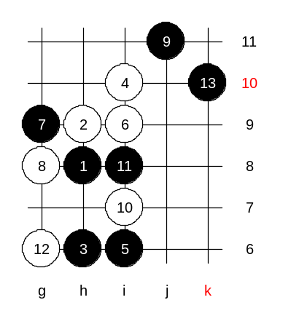
Finally, 13-k10. The move that many of you waited for a long time.
What are the possible white blocks here? This 13th move has been very deeply analysed since 1997.
Next week we will start discussing different possible 14th moves here.

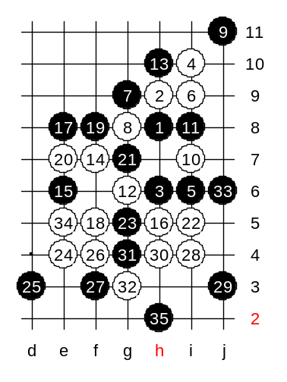

This is the medium level homework. Please find the white win.

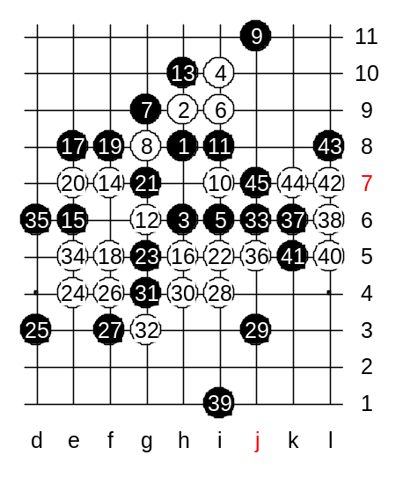

This is the advanced level homework. Please find the white win.

